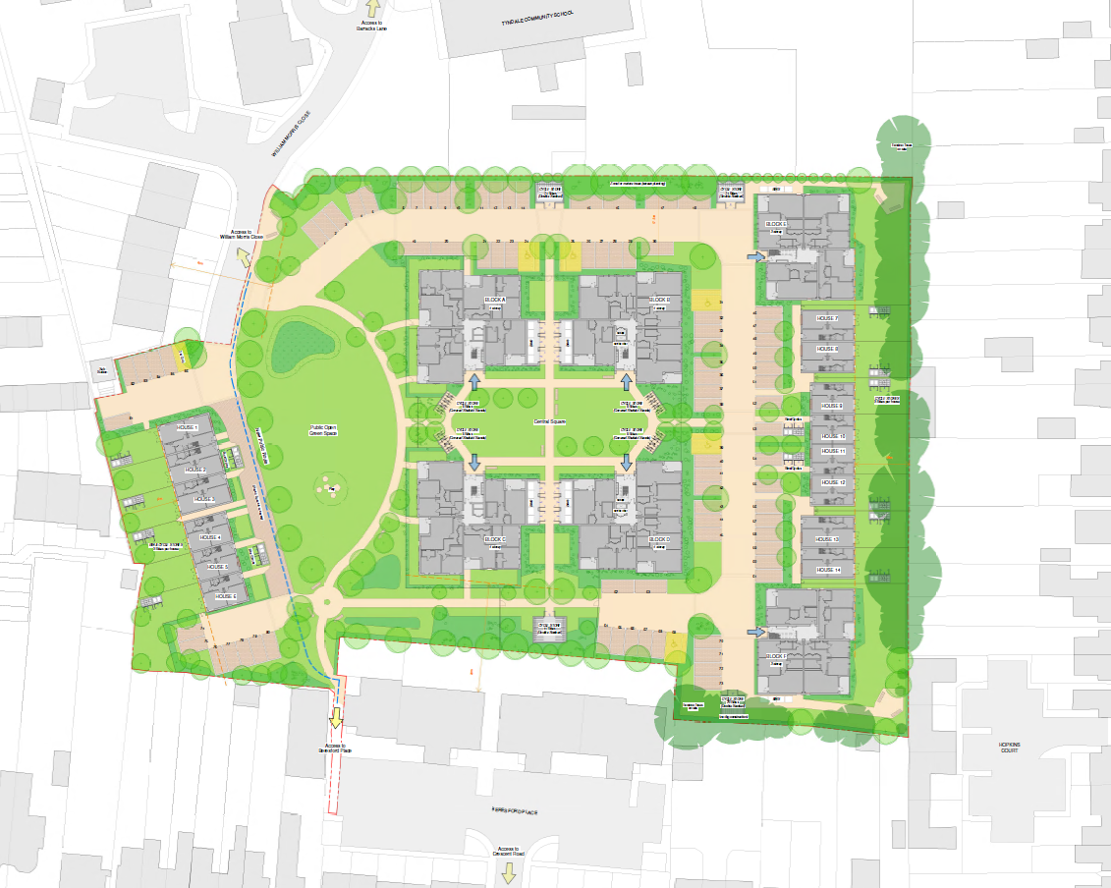
Appendix 2 – Approved Outline Site Plan (18/03330/OUT)

